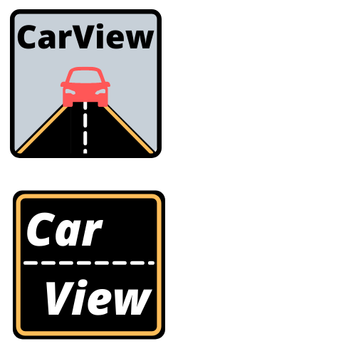

**Mobile & IoT Computing Services**

Spring 2022

Tanishq Agrawal

Steph Muller

Quinn Tian

Reid Yesson

**Table of Contents**

**EXECUTIVE SUMMARY**……………………………………………………………….3

**PROBLEM & MOTIVATION**……………………………………………………………3

**BUSINESS ANALYSIS**

User Research…………………………………………………………………..4

Minimally Viable Product……………………………………………………….6

Competitive Analysis…………………………………………………………....6

Business Model………………………………………………………………….8

**DESIGN & USER EXPERIENCE**

User Personas…………………………………………………………………..11

User Interface: Wireframe Prototype………………………………………….11

User Interface: Application Prototype…………………………………………15

Product Design Concerns………………………………………………………

**PRODUCT**

User Feedback………………………………………………………………….

Think Aloud Testing…………………………………………………………….

Product Safety………………………………………………………………….

Application Architecture………………………………………………………..

**PRIVACY & SECURITY**……………………………………………………………….

Security……………………………………………………..…………………..

Privacy…………………………………………………………………………..

Privacy Nutrition Label…………………………………………………………

**CONCLUSION**

Future Implementations………………………………………………………..

**APPENDIX**

Citations…………………………………………………………………………

Work Division……………………………………………………………………

Initial Survey Responses………………………………………………………

Pricing Survey Responses……………………………………………………

Think Aloud Protocol……………………………………………………………

**EXECUTIVE SUMMARY**

CarView is an app seeking to streamline needed smartphone functionality for drivers. CarView will bring together navigation, audio, and phone calling into a simple, easy-to-use dashboard that will help minimize driver distraction without loss of functionality. Furthermore, it will step into the gap left by Android Auto and Apple CarPlay, which remain limited to certain vehicle makes, models, and model years. CarView, in contrast, will be available to any user with a compatible smartphone, regardless of the car they drive.

**PROBLEM & MOTIVATION**

According to the National Highway Traffic Safety Association (NHTSA), there were 986,000 traffic crashes affected by distracted driving in 2019 - 15% of the total number of crashes - and 61,000 traffic crashes specifically connected to cell phone usage.1 How to best address and reduce these crashes is a challenge facing our society. Many states have enacted laws aimed at addressing this risk, with 24 states banning handheld cell phone use and 48 banning texting while driving.2

Addressing this risk at the source, by changing the way drivers interact with their phones while driving is another approach that is being explored. In 2014, Apple CarPlay was introduced and Android Auto followed quickly in 2015. These systems attempt to streamline and limit interactions with cell phones while driving, simplifying common tasks performed while driving and increasing the use of hands-free voice commands to minimize distractions. but are not universally available - they are only offered in certain vehicles (or vehicle stereo systems) made in or after the year these services were introduced. With 276 million cars registered in the US and the average age of those vehicles being 12.1 years - older than both Android Auto and Apple CarPlay - there is a significant number of drivers who own a smartphone (like 85% of adults in the US), but do not drive a vehicle new enough to have Android Auto or Apple CarPlay.3, 4, 5 Furthermore, recent studies suggest that Android Auto and Apple CarPlay still cause significant driver distraction, and when used via touch (as opposed to voice) may even have a worse effect on driver reaction times than using a handheld device.6 The lack of universal access to Android Auto and Apple CarPlay and the limited improvements they offer in driver reaction time (and ergo in driver distraction) comprise the gaps CarView can aim to address.

**BUSINESS ANALYSIS**

**User Research**

Our first step in evaluating our potential product was conducting a user research survey to understand whether potential users might value an app such as CarView and what usage scenarios it might need to fit.

We structured our survey into four sections, the first was basic respondent information, the second was on the respondents’ general habits as a driver, the third was on the respondents’ use of navigation services while driving, and the final was on the respondents’ use of audio and phone functionality while driving.

The sections comprised of the following questions:

**Basic Information:**

1. Respondent’s age range
2. Do you own or drive a vehicle?
3. Do you own/use a smartphone?

**Vehicle Owner or Driver Section:**

1. What is the approximate age of the vehicle you primarily use?
2. Is your vehicle able to connect with your smartphone via Bluetooth, a cable, or any other method (to play music, answer calls, etc.)?
3. Does your vehicle support Apple CarPlay or Android Auto?
4. How often do you drive?
5. How frequently do you…
   1. Drive Familiar Routes
   2. Drive to New Places
   3. Commute
   4. Drive on the Highway
   5. Drive in a City
6. If you commute via car, how long is your commute?
7. Do you ever use your phone for directions/navigation while driving?

**Navigation Section:**

1. How often do you use your phone for directions while driving?
2. When using your phone for directions, do you search for your destination before you begin driving or while you're driving?
3. Do you ever make changes (add stops, search for gas stations, select an alternate route, etc.) to your navigation while driving?
4. How do you keep your phone in your view while using it to navigate/for directions while driving? (Select your most common method)
   1. Hold phone in your hand
   2. Hold phone in your lap and glance down at it as needed
   3. Keep phone in a cup holder/elsewhere and look down at it or lift it up when checking directions
   4. Dedicated phone holder that attaches to your car (i.e. sits in cup holder, suctions to windshield, clips to air vent, etc.)
   5. Other (Open Entry)
5. Do you have difficulty keeping your phone in view when using it for directions while driving?

**Phone & Audio Section:**

1. Do you ever use your phone to make calls, send texts, or play music while driving?
2. Which of the following do you use your phone for while driving?
   1. Making calls
   2. Answering calls
   3. Reading/receiving texts (either by eye or with voice feature)
   4. Sending or replying to texts
   5. Playing music or other audio (starting, pausing, skipping songs, adjusting volume, etc.)
3. Do you have difficulty doing any of the following while driving?
4. Do you use any of the following audio apps while driving?
   1. Spotify
   2. Apple Music (iTunes)
   3. Apple Podcasts
   4. Youtube
   5. Youtube Music
   6. Music Player (an Android App)
   7. Pandora
   8. Other (Open Entry)

In total, we received 37 responses. 62.2% of those respondents were between the ages of 25 and 35, but our respondents ranged in age from 18 to over 65. 78.4% of our respondents own a vehicle (and an additional 13.5% drive), 100% of them own or use a smartphone (with approximately a 65%/35% Apple vs. Android split), and 94% of respondents who own or drive a vehicle use their phones for navigation, audio, and/or phone functionality while driving.

One of the key initial supports for pursuing CarView from this survey was our finding that, among our survey respondents, 47.1% do not have a vehicle that supports Apple CarPlay or Android Auto. This contrasts with the 94% of users who report using their smartphone while driving, and suggests that there is a gap where users lack an optimized, distraction-minimizing way to use their smartphone while driving that CarView can address.

**Minimally Viable Product (MVP)**

The results of our user survey helped inform the features and functionality needed for our MVP. As 94% of our respondents who drive and own a smartphone use their phones for navigation, and 78% of them do so at least once per week, we designated navigation as the top priority feature to enable. Much of the anticipated benefits of CarView come from its ability to integrate features and functionality from several apps and native phone features, enabling audio and phone functionality were our secondary priorities.

Among the phone and audio functions, answering calls and playing audio were the most common tasks performed by our survey participants (with 94% and 88% respectively performing each task while driving). As our respondents were divided between Android (35.3%) and Apple (64.7%) device usage, focusing on OS-specific audio players like Apple Music seemed inefficient. This was reinforced when only 12.5% of our respondents indicated that they used Apple Music. Instead, the top audio app was Spotify, which was used by 43% of our respondents. For these reasons, enabling calls and use of Spotify through CarView became our second and third features for the MVP.

**Competitive Analysis**

We initially identified Android Auto and Apple CarPlay as our major competitors. Both operate via a built-in display in the user’s vehicle and enable the user to navigate, make calls, send and receive texts, play audio, view their calendar, and use other apps and smartphone features.7, 8 CarView will not win against these competitors from a features and functionality standpoint, our aim is not to enable all of the features and functionalities currently offered by Android Auto and Apple CarPlay. Instead, we will focus on enabling only the core features - navigation, audio, and phone calls.

With less functionality to offer, CarView’s primary advantage over Android Auto and Apple CarPlay will be that it is available to the driver of any car (so long as they have a compatible smartphone) - requiring no modifications or upgrades for use. Android Auto and Apple CarPlay are both systems that are built into a vehicle’s entertainment system - or into an after-market entertainment system that must be installed into an existing vehicle. This means that these systems are unavailable to many potential customers - any customer with a car too old to be or otherwise not enabled with Android Auto or Apple CarPlay and without the means to upgrade their vehicle’s entertainment system has no access to these solutions. This is the gap CarView seeks to fill, and given that there are approximately 276 million vehicles registered in the US and that the average age of these vehicles is 12.1 years, 3-4 years older than Android Auto and Apple CarPlay, we expect there is a sizeable market for CarView to target.3, 4

System controls are another area where CarView will differ and potentially fall short of these competitors. As systems that are fully integrated with the vehicle, both Android Auto and Apple CarPlay can be controlled by the car’s controls. CarView, which will be fully contained within the user’s smartphone, will not benefit from such complete integration with the car - it will need to be controlled via the phone’s controls. Our plan for addressing this limitation is to enable voice commands to the greatest extent possible. Per research conducted by IAM RoadSmart and TRL Limited, there is evidence to suggest that touch control of Android Auto and Apple CarPlay has a greater negative impact on driver distraction than voice control of the same systems. We hope that by enabling voice commands through CarView, we can optimize use of the enabled functions while driving and add value for our customers.

An unexpected competitor group we also need to consider are the smartphone voice assistants. As we expect voice commands may become a significant aspect of CarView, we need to consider whether CarView offers any additional value beyond the voice assistants. While we’re in the early stages of evaluating this, we have found that the voice assistants can be complicated to use. Siri, for instance, defaults to Apple Maps and a recent attempt to use voice commands through Siri to pull up directions via Google Maps resulted in several minutes spent attempting to identify the correct command that would use Google Maps and not try to pull up Apple Maps. This is an example of the “mighty user memory,” here for specific voice commands, that is sometimes required to effectively use voice assistants to achieve exactly what the user desires, and not have the user be controlled by the system’s defaults and preferences. This failure to adhere to several of Lund’s usability maxim’s is a potentially serious limitation of the voice assistants. We are unsure if we can avoid these issues, but by combining voice commands and CarView’s dashboard, with all of the needed information relevant to the driver’s navigation, audio, and phone use, we hope to create a more usable solution.

**Business Model**

Carview being a service provider for automobiles not providing in-built Bluetooth/Android Auto/Apple Carplay, we have to be very tactful while finding our target market. By doing a user and market study, we found that we can target five potential markets broadly.

1. Individual car owners
2. Rental car services
3. Pre-owned car sellers
4. Two-wheel automobile owners (Potential Future Markets)
5. Tuk-Tuk drivers in developing countries (Potential Future Markets)

**Initial Plan**

In the beginning, we want to start slowly by targeting the potential users in the Pittsburgh region. We will also try to partner with rental car services where we can provide our services for their older cars. Apart from that, we will try to enter into a partnership with a local pre-owned car seller who can help us advertise our product directly to the target customer.

By starting small we will be able to focus on weaknesses of our product as well as we will be able to provide better customer service in the Pittsburgh region initially, as we want to keep our cost as low as possible initially. This would also help us study our users more closely and find any other pain points which we can provide solutions to.

**Promotion Strategy**

For promotion, we will be using targeted ads, especially on Facebook groups that deal with selling old cars, as well as, we try to get into a partnership with pre-owned car sellers who will suggest our product to the customers buying cars with no built-in system for connecting cars with a smartphone.

Apart from this, we will also use traditional media advertisements like flyers, newspaper ads etc.

**Pricing Strategy**

In the early stages of our user research, in our initial survey and in our user interviews, we received a lot of feedback that CarView was not something users would be willing to pay for. However, as an app that broadly falls into the productivity category, a paid app model in theory would make sense for CarView. Per Distimos’ “2013 Year in Review,” 70% of productivity apps use paid app models. Additionally, in our conversations with Professor Sadeh, he expressed concern with how an advertising-supported model would work - we would not want the ads to be an added distraction while the user is driving and we have little that would induce the user to keep the app open to view ads once they were done driving.

This dichotomy between what we were hearing from our potential users and what we understood to be the established best practice and likely the best practice for practical reasons, led us to conduct further user research in the second phase of our project. To this end, we conducted a second user survey, this time focused on evaluating a potential user’s willingness to pay for CarView. We received twenty responses and in this survey, we asked the following questions:

1. Do you already have Android Auto or Apple CarPlay?
2. Assuming you did/do not already have Android Auto or Apple CarPlay, would you be interested in CarView as it's described above?

*We asked respondents to answer the following questions as if they were interested in the CarView app and did not have Android Auto, Apple CarPlay, or any other alternatives.*

1. What payment model(s) would you be open to for an app that would offer functionality and streamlined smartphone use while driving as described above?
   1. Monthly Subscription Fee
   2. Per-Use Fee
   3. One-Time Fee
   4. Not Willing to Pay/Prefer In-app Advertising
2. What is the most you would be willing to pay as a ONE TIME FEE for an app that would offer similar functionality and streamlined use while driving?
3. What is the most you would be willing to pay as a MONTHLY SUBSCRIPTION FEE (cancellable at any time) for an app that would offer similar functionality and streamlined use while driving?
4. If this app was available at no cost to you, would you be comfortable sharing your location information with the app for advertising purposes?
5. If this app was available to you at no cost, would you be interested in seeing ads for nearby or local businesses when you use the app?

In contrast to our earlier user feedback, this survey did reveal that potential CarView customers would be willing to pay for our app. Only 30% of our respondents indicated they would be entirely unwilling to pay for CarView, suggesting that 70% of our survey population would be willing to pay for the app, depending on the payment model and price. We also asked respondents to indicate which payment models they would be open to for CarView and learned that sixty-five percent of them are open to a one-time fee and forty percent of them are open to a monthly subscription model.

Given the greater openness to a one-time fee model, we have elected to focus on this payment model for CarView. When specifically asked about a one-time fee for CarView, our survey respondents indicated that more than half of them would be willing to pay at least eight dollars for the application. An additional twenty-five percent of our respondents were willing to pay between four and six dollars. This gives us a fair amount of flexibility on the price we can set for a one-time fee. We aim to set the ultimate one-time price for CarView at a rate that will allow us to maximize our revenue such that our costs are covered and the app generates profits.

With this information on our potential customers’ willingness to pay as well as with information on our costs, we can begin to narrow in on the appropriate price point for CarView. For the Google Maps API, we know that $5 purchases around one thousand uses of the Directions API.9 Based on our initial user survey, we were also able to estimate the navigation usage of our potential customers (shown in Figure 1). Our largest customer segments are projected to use CarView for navigation weekly or multiple times a week, yielding between four and fifteen calls to the API a month. At a $5 price point, based on the pricing from Google, these users would be able to use CarView at this rate for a minimum of 66 months before exceeding the value they paid CarView. For the multiple uses daily segment, we estimated 60 uses of the API per month, at which rate their $5 fee would be exhausted after 16 months of use. Our ability to successfully price CarView through a one-time fee will depend on the accuracy of our customer usage segmentation and their total lifetime usage (i.e. how many months the customer will use CarView for and whether they maintain the same level of usage throughout that period). Unfortunately, we do not have a way to project lifetime usage at this time, as it is dependent on many factors including how long customers hold on to their vehicles (as upgraded vehicles may offer Apple CarPlay and/or Android Auto to the customer and render CarView unnecessary) and how long they find CarView valuable or useful (it could also become less useful as the user becomes more familiar with their driving routes). Ultimately, we would be looking to find a price point where our heaviest users, the multiple uses daily segment, are subsidized by our lower-usage customers, but that is not so high as to discourage lower-usage customers from purchasing CarView.

**Future Potential Markets**

In future, we want to expand CarView to not only two-wheeler automobiles but also to the Tuk-Tuk (Three-wheel automobiles) in developing countries. As the world gets more connected to the internet, internet-based services coverage would also increase with time. In most developing countries, two/three wheel automobiles are being used for travel (Uber/ Ola in India), last-mile delivery (from groceries to Amazon parcels) etc. This could be a big target market for us as the drivers use all the functionalities provided by our product.

**DESIGN & USER EXPERIENCE**

**User Personas**

There are two primary user personas we’re considering for CarView. The first persona is a commuter, driving the same route back and forth to their job. The second persona is a traveler, driving an unfamiliar route to a new destination.

Our commuter persona represents approximately 40% of our survey respondents, who indicated that they commute more than 4 times a week. These users will not need CarView for its navigation functionality, but they may desire the traffic, construction, and speed trap alerts from the navigation system. Beyond those alerts, the main benefits CarView can offer these users are streamlined controls for their audio and phone calling.

Our traveler persona represents nearly all of our survey respondents at some point - almost 92% of them indicated they drove to somewhere new at least a few times a year. These users will primarily be interested in CarView’s navigation functionality - they will want reliable routes with an easy ability to add gas, food, rest, and other stops. They will likely also be interested in traffic, construction, and speed trap alerts, and may desire easy changes to alternative routes. The audio and phone calling features will likely also be important to them, as they may help pass the time on long road trips or help coordinate with others they may be visiting or traveling with.

**User Interface: Wireframe Prototype**

The design of the UI makes sure on any of the screen, the user can go to map, or music, or take incoming phone calls with just one tap. It has large texts and buttons for the good view and the easy operations on the road.

Our wireframe prototype is created in Figma and address the following user tasks::

1. Log in via Google or Spotify

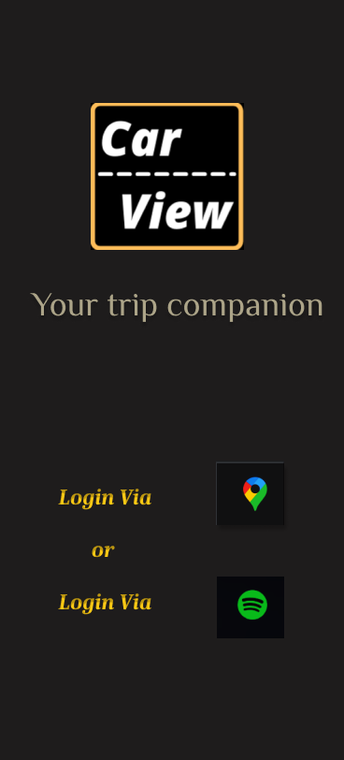

Users can log in by tapping on the Map button or Spotify button.

2. Driving with navigation and listening to music

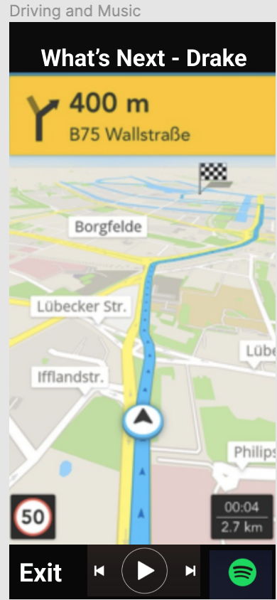

The top bar has the song’s name and the artist. Tapping on it would go to the music page with that song. The main screen in the middle shows the navigation map with directions, etc. The bottom bar has the controller pad for the music player, play/pause button, the previous song and the next song button. The Spotify button on the right bottom leads to the music browsing page in Spotify. The ‘Exit’ button would get you back to the login screen.

3. Listening to music while driving

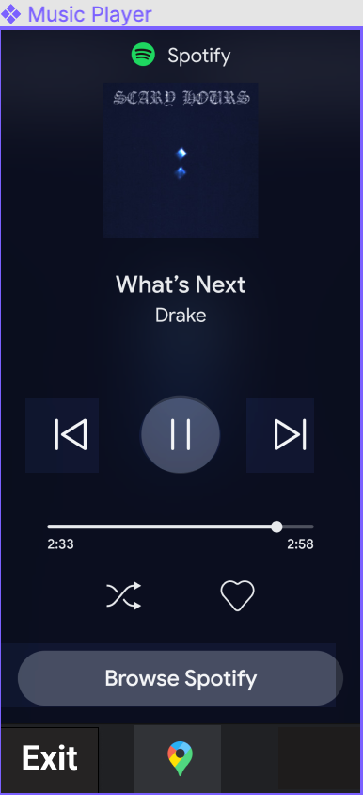 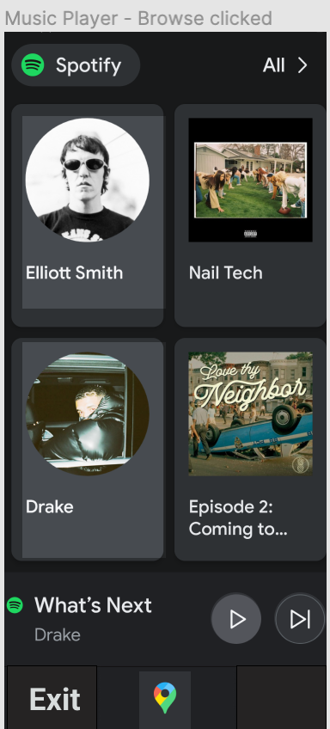

In the Spotify screen, the controller pad for the music player is in the center of the screen, so the users can easily tap on the play/pause button, the previous song and the next song button. The ‘Browse Spotify’ button leads to the music browsing page in Spotify, as the picture below. Clicking on any song on the browsing page would go to the music player page again. The map button at the bottom is for users to switch to the map page with only one tap.

4. Taking/dismissing phone calls while driving

The below ‘Incoming phone call’ screen shows what users see while a phone call comes in. The big yellow text shows the caller ID, the user can pick up the phone call by tapping on the green button, or dismiss the call by tapping on the red button. The screen would come back to the navigation page automatically while the call is hung up.

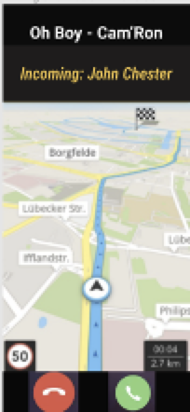

**User Interface: Application Prototype**

[kunt@andrew.cmu.edu](mailto:kunt@andrew.cmu.edu)[ryesson@andrew.cmu.edu](mailto:ryesson@andrew.cmu.edu) **- Please describe your progress in application development**

**Product Design Concerns**

While developing our application prototype, a few product design questions came up for CarView. The first was regarding sound prioritization in the app. The three main features CarView combines - navigation, phone calls, and Spotify - all have audio components to them and all may attempt to play audio simultaneously through CarView. The Spotify audio was easy to identify as our lowest-priority audio - in general, this audio would be optional music, podcasts, or other recordings that should be deprioritized in favor of a voice call or navigation narration. Determining whether navigation audio should supersede phone call audio was slightly more challenging. From Google Maps, which offers similar functionality, we learned that navigation audio does continue to play even when a user is conducting a phone call. This supported our conclusion that the navigation audio should have top priority, especially as users who do not care to hear the navigation audio will be able to disable it entirely, as they can in Google Maps. This left us with an audio prioritization of, from highest to lowest priority, navigation audio, phone call audio, and Spotify or other audio.

Another product design concern that arose was the similarity to Google Maps in terms of functionality. A smartphone user can set up Google Maps to direct them to their desired destination and have basic control over their active Spotify or select other audio player sessions through the app. The user is also free to answer a phone call that comes in while the navigation is open. The key difference that CarView will offer is full control of these other functions within the app. With Google Maps, a user must exit Google Maps and open their phone app in order to place a phone call, end their current call, or perform any other phone functions. Similarly, while an active audio session in several of the most popular audio playing apps can be controlled (at least in terms of the basic pausing, playing, and skipping forward or backward functions) within Google Maps, a user cannot directly begin playing a new audio session from within Google Maps. The full integration of Spotify, phone functionality, and Google Maps into CarView will mean that a user can start a brand new audio session or place a phone call directly from CarView, without having to take the time (and have the added distraction of) opening and closing other apps. As discussed in the Competitive Analysis section, we expect that having full control of all of these functions in a single dashboard will also reduce the need for a “mighty user memory” in order to effectively use voice commands. Having a simple visual display showing the current status of each of these features should help prompt a user to better identify the voice commands they wish to use.

**PRODUCT**

**User Feedback**

In the early stages of our project, we conducted a usability test on our Wireframe Prototype. Given the limited functionality of our Figma prototype, the tasks we set for our interviewees were very simple. After introducing CarView as an application intended to be an all-in-one dashboard to control your navigation, audio, and phone calls while driving, we asked the interviewee to simply attempt to navigate the app, answer a simulated phone call, and manipulate the audio session. From conducting these informal think-alouds with a handful of users, we received the following feedback:

* Need to be able to browse the music while using navigation
* ‘Receive Call’ button blocked the view of map
* While the phone call comes in, I need to click twice to take/dismiss the call. Why not one click?
* Dislike having to log in twice
* Cannot see song’s name on iPhone, it’s cut off
* “Probably wouldn’t buy it on the App Store”
* Consider SiriusXM, Apple Music?

In response to these specific points, we made the following adjustments:

* Added a ‘Spotify’ button on the right bottom to connect to the ‘Browse music’ screen
* Deleted the ‘Receive Call’ on the navigation
* When a phone call comes in, automatically jump to incoming call screen
* Only one sign up or log in - using Spotify’s or Google’s authentication
* Moved the song’s name down for iPhone screen
* Focusing on a free with ads model, conducting further research
* Future implementations can include more music sources

**Think Aloud Testing**

Once we began developing an initial full prototype of our CarView app, we designed a protocol for Think Aloud testing of the app. By conducting Think Aloud testing we are hoping to evaluate three research questions:

1. Is the UI sufficiently simple to use while distracted and the majority of the user’s attention must be elsewhere (i.e. on driving, their primary task)?
2. Does using CarView while (simulating) driving result in a significant reduction in driving performance?
3. Can the user successfully accomplish the specified tasks using the interface?

Our full test procedure is available in the appendix, but in general the plan is to ask our participants to complete several control trials of a driving simulator and then, once familiarity and baseline performance are established, introduce CarView and ask the participant to complete several tasks using CarView while repeating the driving simulation. We plan to capture notes on the user’s interaction with CarView and their driving simulation performance during both the control and test trials in this document: [CarView Think Aloud Results](https://docs.google.com/spreadsheets/d/1379rBda3xIjR7yMrnCmYzxHmcwY-EnHA0dT207Jkj-w/edit?usp=sharing).

Conducting these Think Alouds is dependent on development of a functional application prototype. As we have encountered greater difficulty developing the application than expected, we will not have time to complete the prototype and perform these think aloud tests before this report must be submitted. At this point, the Think Alouds are the next step in our product development plan.

**Product Safety**

Safety of the user is at the forefront of CarView with users using our product in conditions(driving) which can cause fatal accidents. We have strictly adhered to the guidelines and rules made by the National Highway Traffic Safety Administration(NHSTA) regarding the usage of cell phones while driving. We ensured that the user does not handhold the phone while receiving a call and at the same time we have not added the functionality of messaging while driving as it is against the law in quite a few states in the USA.

According to the NHTSA data for 2020 around 8% of all fatal car accidents are caused to due to distracted driving. So we at CarView are trying to reduce driver distraction as much as possible. A study conducted by a UK based road safety organisation, IAM RoadSmart in 2020 on using Google Android Auto and Apple CarPlay while driving came up with rather shocking findings. They found that though these apps provide users with convenience but using them seriously reduces a driver's reaction time. They found that using these applications has the worst effect than drinking and driving.

This study also found that drivers often underestimate the time they looked away from the roads while operating these applications. Using voice command had a better result than using a touchscreen interface but still had quite a delay in reaction time. With the world running on gadgets and as our lives are getting connected with the internet more and more this has a become a serious issue. We at CarView would be being out the voice assistant soon so that atleast drivers do not have to use the touchscreen interface which will significantly improve their reaction time compared to using a touchscreen interface.

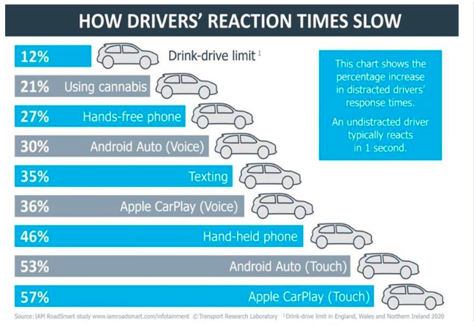

Fig. Driver’s reaction time

**Application Architecture**

Although many of our survey respondents were iPhone users, we still project there to be a large market of Android users that currently drive older vehicles. We choose React Native, a cross-platform development environment with great documentation, so both IOS and Android phone users can be covered.

The implementation started with the first version of Vanilla React Native application, then it was found to be not friendly for tab navigation and backend implementation. The second version is the React Native Expo project, with React Navigation added. This fits into our tabs navigation design with ‘Map’ and ‘Spotify’ buttons in the bottom tabs bar, which is easy for users to go to all screens. It can configure the nested stack navigation as well, which is needed for the Spotify account login process. The backend Spotify API authentication and API calls to Spotify and Google Map Directions can be implemented in this version too.

We have applied Expo AV for sound playing, Redux for state management, Axios for data fetching, react-native-deck-swiper for swiping song screens, and expo-auth-session for the actual authentication. The current MVP version stores Spotify account login locally, so no database in the cloud is used.

For the future full implementation, our architecture design is React Native Expo project with TypeScript for the front end, AWS Amplify, AWS AppSync and GraphQL for the backend. TypeScript is to manage different types of components/objects. Amplify Console is good for continuous deployment and hosting of full stack web apps. Cloud resources created by the Amplify CLI are also visible in the Amplify Console. All users and developers access data can be stored in Amplify. AWS APPSync enables us to manage and synchronize app’s data in real time across devices and users. GraphQL is great for fulfilling queries with existing data at runtime. The draft for this version with the front end demo is here: <https://github.com/quintian/carviewApp.git>.

**APIs**

As stated above, we will be using the Spotify library along with the Google Maps API to make requests to their API endpoint. We will use the Google Maps Navigation API. Based on the pricing, we made the decision to use Google Maps due to its user friendliness and acceptance across the market.

With regards to pricing, Google offers a $200 monthly credit, which is approximately equal to 28,500 free maploads per month.

**Figure 1**: Total user estimates to stay within the free level for Google Maps’ Navigation API (Percentage of users in each group based on our user survey data):

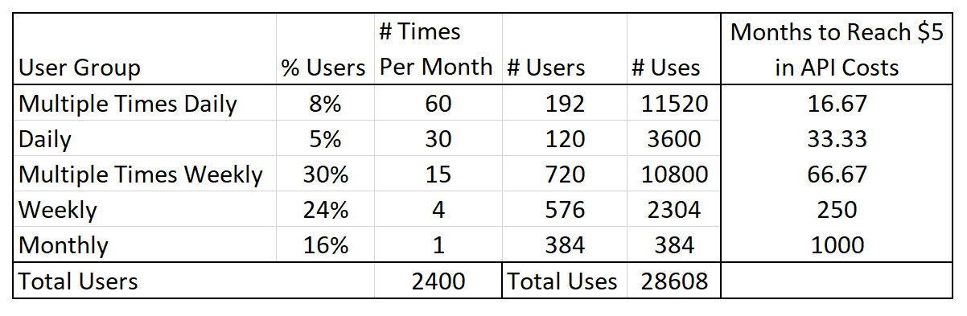

**PRIVACY & SECURITY**

**Security**

Because the CarView App accesses users' contact information, phone call, location and address, the authentication of users is crucial for the protection of the data. Logging in via 3rd party authentication is both safe and convenient for users. We decided to use Spotify OAuth or Google Oauth since our App is a combination of both features.

The usage data will not be saved, but we still track the number of users and API calls. This operational data will be saved in MongoDB anonymously for protecting users’ security and privacy.

With the risk of eavesdropping and attacks over the cellular network or Wifi, we will encrypt the communication between the mobile device and the server. Session keys or SSL keys are considered for encryption of the data in transmission. The sensitive data stored in local devices shall be encrypted too. No usage data will be retained or given to a third party.

We take account of the scalability while designing the business model, so the App would not be stuck while too many users are coming in.

The App being always responsive is necessary for security too. In case of wrong users input or loss of connections, the error message will be set up to tell the user what to do next. For example, if a user put in a wrong address, the response would be like ‘try again?’ or ‘not found’.

While considering the in-app purchase model after MVP, all payment would be processed via the App store. This is safer since the App need not take any credit card information.

**Privacy**

For compliance with GDPR regulations, we take the opt-in method and let users choose which permissions they grant in the manifest, such as their location, Call App, Spotify account, speaker, etc.

The privacy policies shall be clearly written and easily understandable and accessible. It will be available in the App’s menu. The users must agree on it before using the app.

We do not retain any usage data and make sure the 3P APIs do not retain or sell any users’ data through the contract with 3p APIs.

Our business model may consider ads-free while total users are below 2000, which also takes account of the privacy issues from the advertisers.

**Privacy Nutrition Label**

Apple Store Nutrition Label:

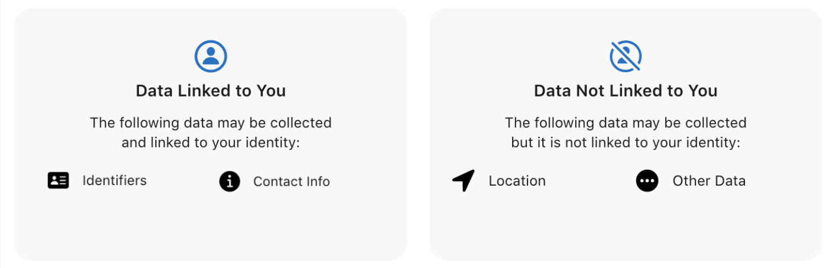

Breakdown of privacy labels:

* Location data is not collected and stored in a database, and only used in the moment to capture and plot GPS coordinates using the Google Maps Directions API. Our app does not store user trips or need them to sign into Google to access Google Maps, so that data would not be linked to their identity. If the user decides to authenticate with Google so that they can access personal data, that GPS data would be linked to their Google Account but only Google would have access to it. Unless there is a security risk in Google’s infrastructure, the integrity or security of the location data cannot be attacked, so it is not linked to you.
* Similarly, contact information is only accessible through the Apple Phone Call API that allows phone calls to be displayed on the app. This information is not recorded by CarView locally or in any other context, nor is it accessible by any other external entity except for Apple, who has access in the first place. We looked at other applications that made use of external calling, like Google Duo and Skype, and saw that Contact Info was generally listed as data linked to you. The only feature our app uses Contact Information for is displaying the name of the incoming caller while the app is in use.
* Google OAuth or Spotify login information is also not recorded by the application locally or in any capacity outside of the one-time authentication that is required to log into Spotify. The information is thereby partitioned from all other vendors,

From the prof: “For each label, make sure to indicate why you chose the answer you chose (e.g., whether you select "yes" or "no" to a question, I expect you to include a line or two of text explaining your selection). When the answer is "yes" (or equivalent), you should include a brief description of the part of the code where a certain data practice is being used (or an explanation of why you don't believe your app doesn't engage in a particular data collection or use practice). Please make sure to carefully read Apple or Google's descriptions of each label. Also, please make sure in your report to include information about the purpose for which each piece of sensitive information is collected (e.g., marketing, advertising, security, core functionality), whether the information is shared with 3rd parties and if so for what purpose, and for how long it is retained.”

**CONCLUSION**

**Future Implementations**

There are several future implementations we are considering for CarView. As discussed in the competitive analysis and in line with the research from IAM RoadSmart and TRL Limited, CarView should expand its voice-enabled functionality in the future to maximize its ability to reduce driver response times and distraction.6 Additionally, per the suggestion of a usability tester, CarView may want to expand into OnStar-type services, using location and accelerometer data to identify potential accident incidents and connect the driver with emergency services.

We originally theorized that CarView may be best suited for pairing with a phone-mount device of some sort, but found only limited support for this idea in our survey. Only 24.3% of our survey respondents indicated they had any trouble keeping their phone in view while using it for directions when driving, which suggested there may not be much need for a complementary phone-mount product. However, 46% of respondents indicated that they leave their phone in a cup holder, on their lap, in their hand, or elsewhere in their vehicle while driving, lifting it into view as necessary when using it for directions which may indicate that with further research we may identify a more subconscious need for such a complementary product.

One other feature we considered adding was the automatic detection of driving while the app was open, or in the background. The driving feature would detect if the user is moving fast enough to indicate they are in a car, and then automatically trigger the navigation feature.

# **Github Links:**

<https://github.com/quintian/carview_player>

# 

**APPENDIX**

**Citations**

1 National Center for Statistics and Analysis. (2021, April). Distracted driving 2019 (Research Note. Report No. DOT HS 813 111). National Highway Traffic Safety Administration. <https://crashstats.nhtsa.dot.gov/Api/Public/ViewPublication/813111>

2 “Distracted Driving.” GHSA, Governors Highway Safety Association, 2021. <https://www.ghsa.org/state-laws/issues/distracted%20driving>

3 Carlier, Mathilde. “Number of Cars in U.S.” Statista, Statista, 13 Jan. 2022. <https://www.statista.com/statistics/183505/number-of-vehicles-in-the-united-states-since-1990/>

4 Colias, Mike. “Americans Are Keeping Their Cars Longer, as Vehicle Age Hits 12 Years.” The Wall Street Journal, Dow Jones & Company, 15 June 2021. <https://www.wsj.com/articles/average-u-s-vehicle-age-hits-record-12-years-11623680640>

5 “US Smartphone Ownership 2021.” Statista, Statista, 12 May 2021. <https://www.statista.com/statistics/219865/percentage-of-us-adults-who-own-a-smartphone/>

6 Ramnath, R, et al. “Interacting with Android Auto and Apple Carplay When ...” IAM RoadSmart, IAM RoadSmart and TRL Limited, 31 Jan. 2020. <https://iamwebsite.blob.core.windows.net/media/docs/default-source/default-document-library/iam-roadsmart-trl-simulator-study_infotainment.pdf?sfvrsn=d873495c_2>

7 “Ios - Carplay.” Apple. <https://www.apple.com/ios/carplay/>

8 “Android Auto.” Android. <https://www.android.com/auto/>

9 Google Maps Platform. Pricing. <https://mapsplatform.google.com/pricing/>

10 Driver’s Reaction Time Figure source: <https://www.iamroadsmart.com/campaign-pages/end-customer-campaigns/infotainment#>

11Article on Distracted driving study conducted by IAM Road Smart: <https://www.auto123.com/en/news/android-auto-apple-carplay-distractions-driving/66872/#:~:text=This%20is%20according%20to%20a,dangerous%20than%20driving%20while%20drunk.>

**Work Division**

| **Task** | **Tanishq** | **Steph** | **Quinn** | **Reid** |
| --- | --- | --- | --- | --- |
| User Survey Design | ✔ | ✔ | ✔ | ✔ |
| User Survey Recruitment | ✔ | ✔ | ✔ | ✔ |
| Whiteboard Prototype | ✔ | ✔ | ✔ | ✔ |
| Figma Prototype |  | ✔ | ✔ | ✔ |
| Usability Interviews | ✔ | ✔ | ✔ | ✔ |
| Mid-Semester Report | Business Model | ✔ | Wireframe Prototype; Privacy & Security; User Feedback; Database | Application Architecture |
| Application Architecture |  |  | ✔ |  |
| Application Prototype |  |  | ✔ | ✔ |
| Pricing User Survey |  | ✔ | ✔ |  |
| Implementation |  |  | ✔ | ✔ |
| Think Aloud Protocol |  | ✔ |  |  |
| Final Report | Product Safety | ✔ | Application Prototype & Architecture | Application Prototype & Nutrition Label |
| Final Presentation | ✔ | ✔ | ✔ | ✔ |

**Initial User Survey**

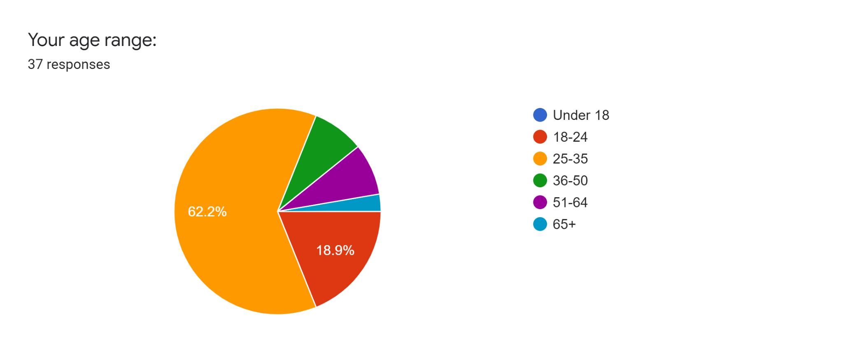

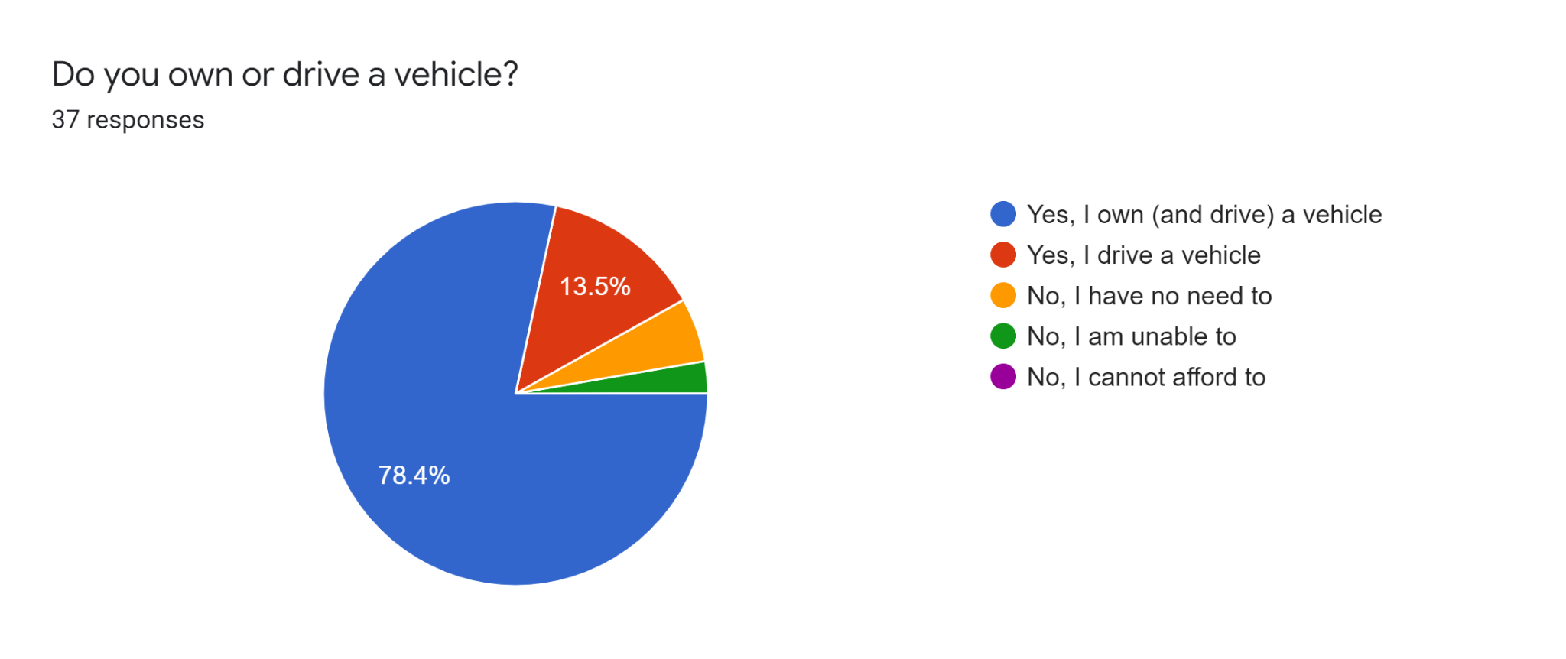

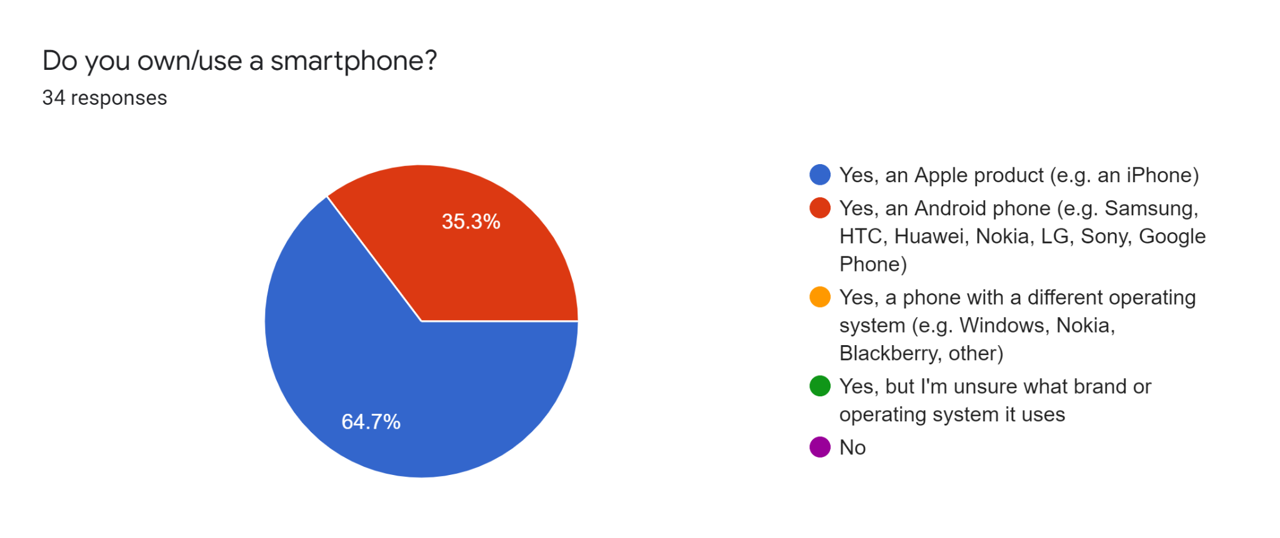

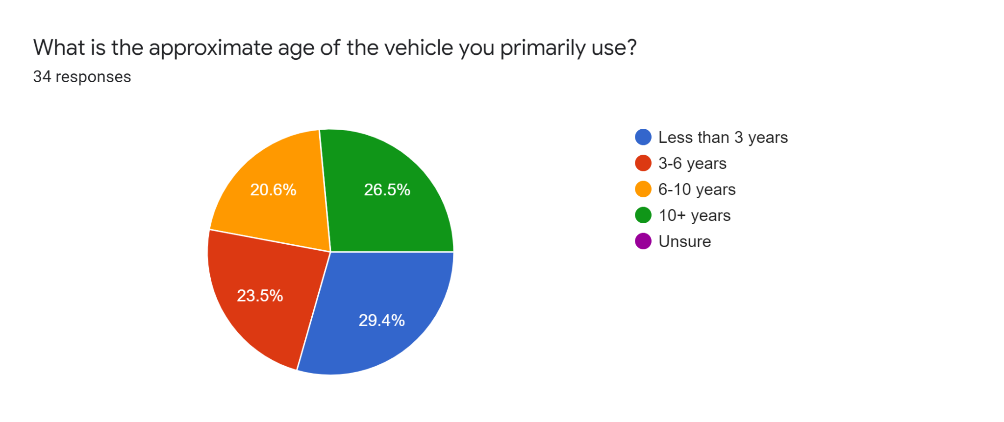

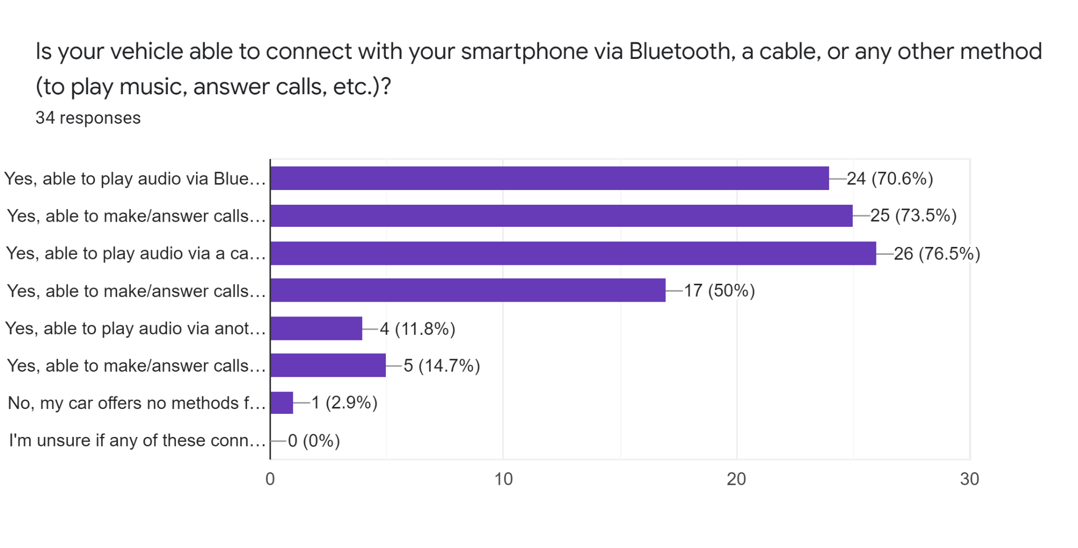

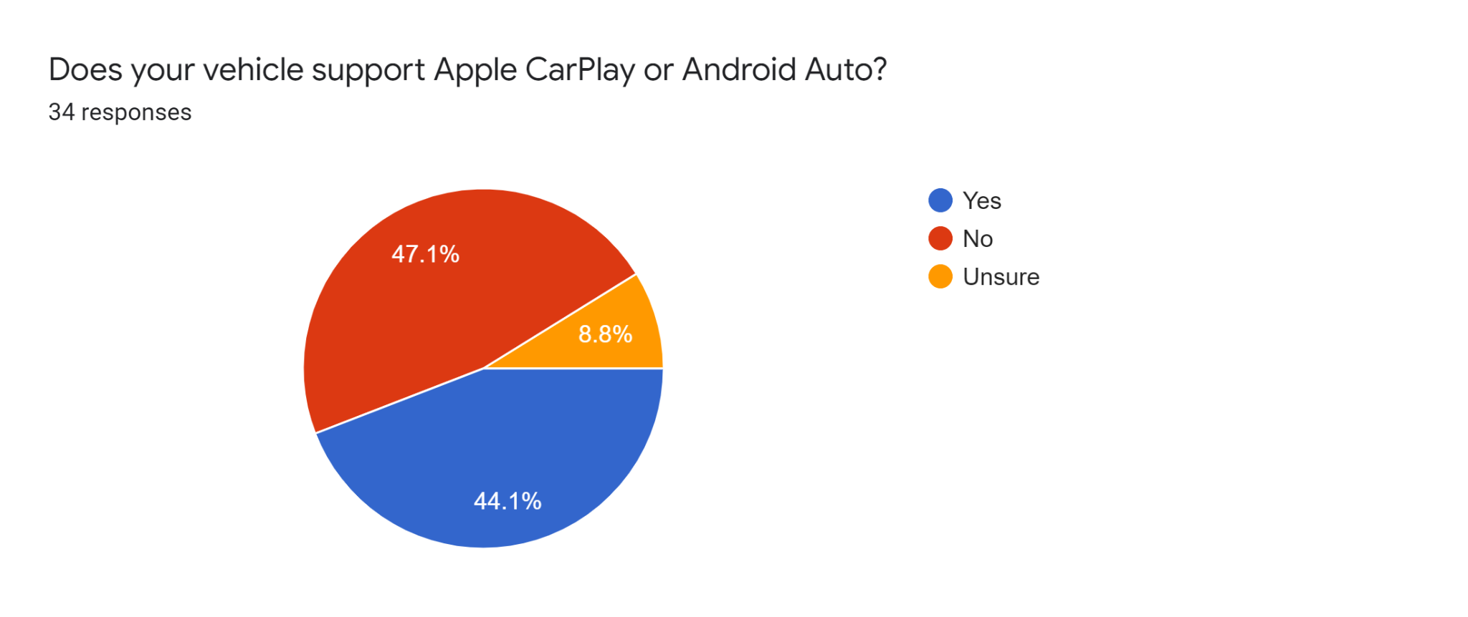

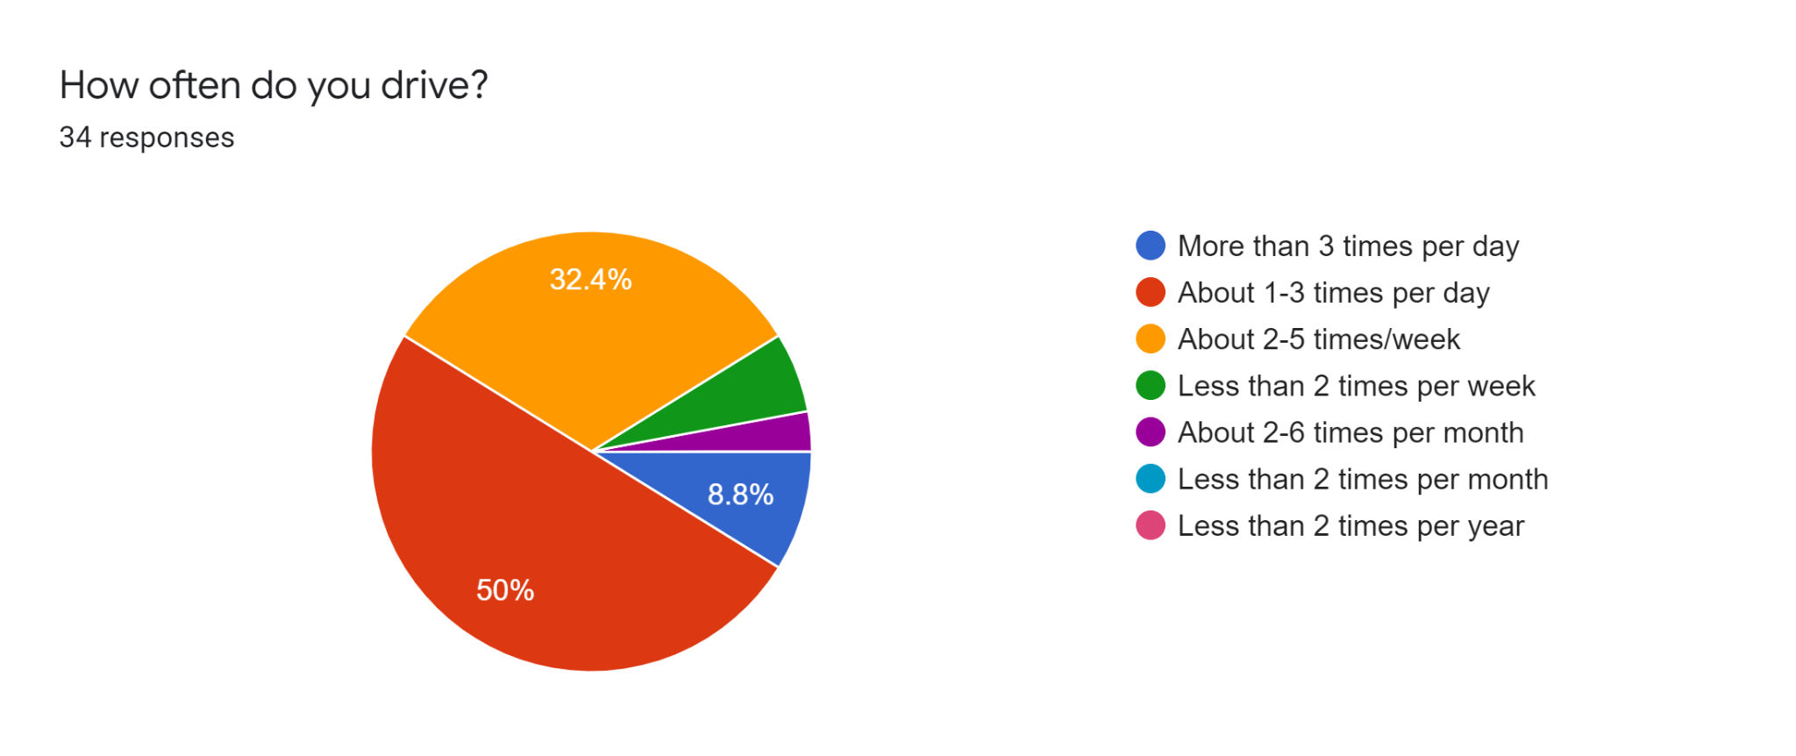

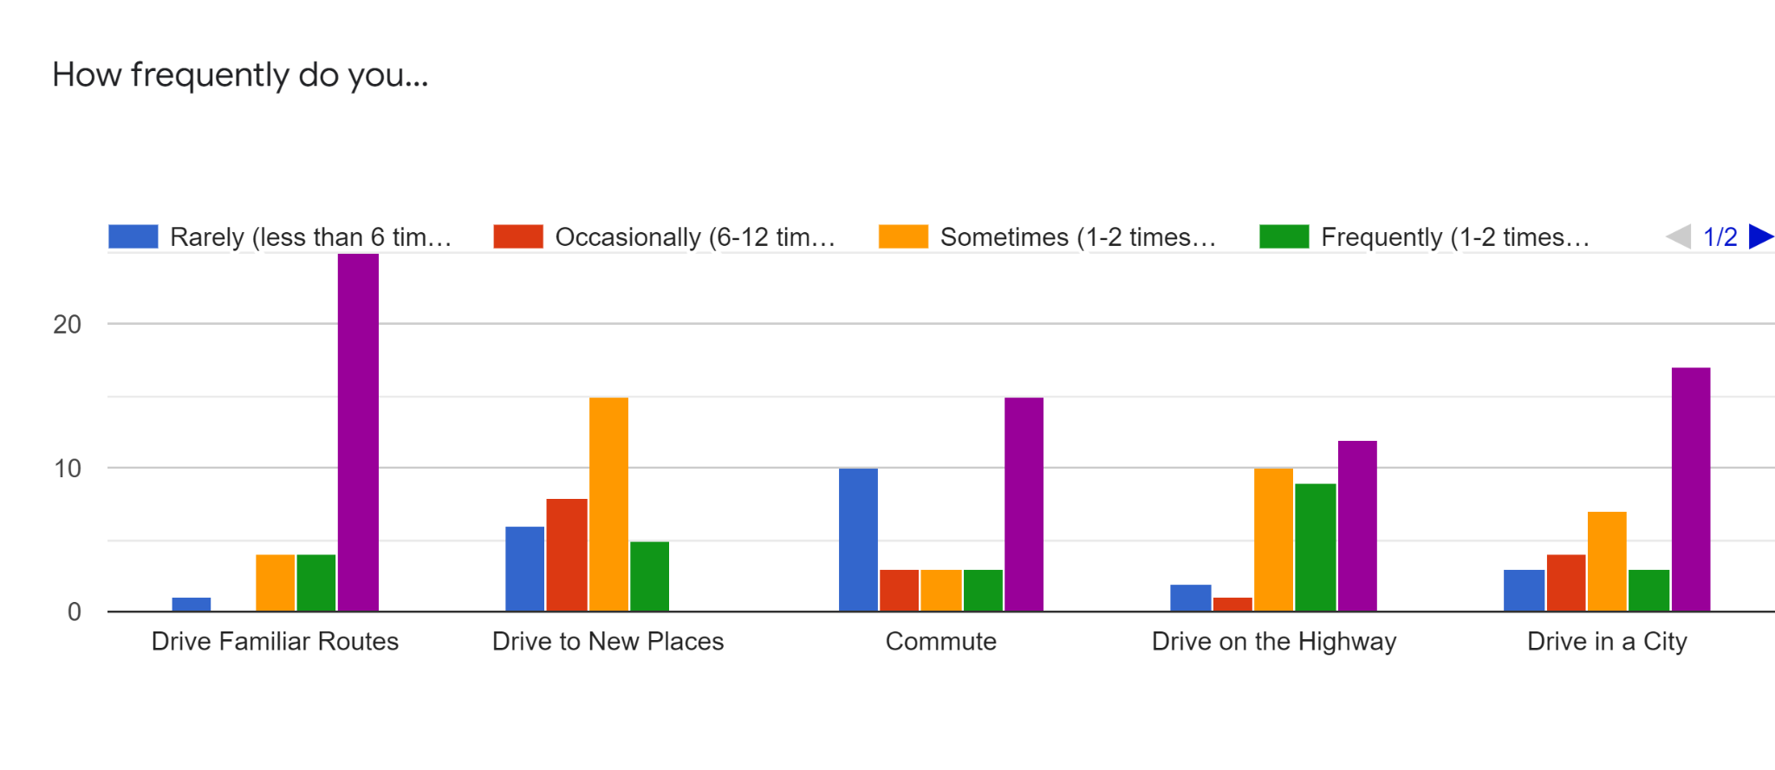

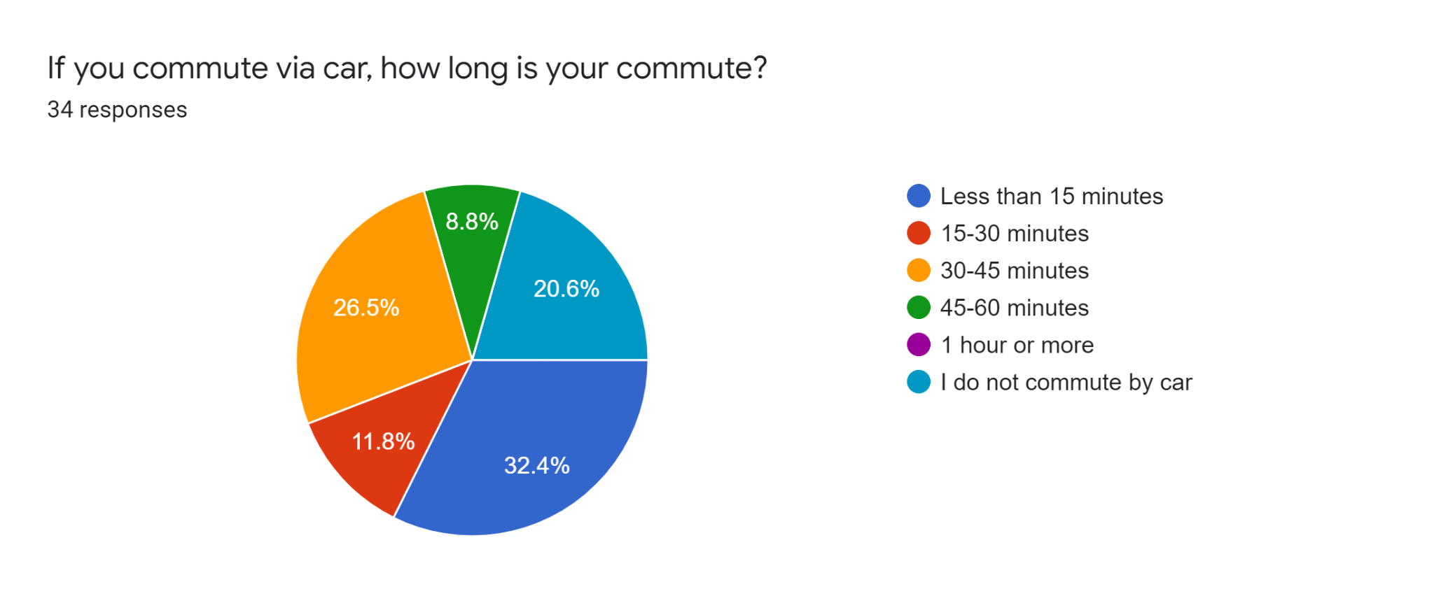

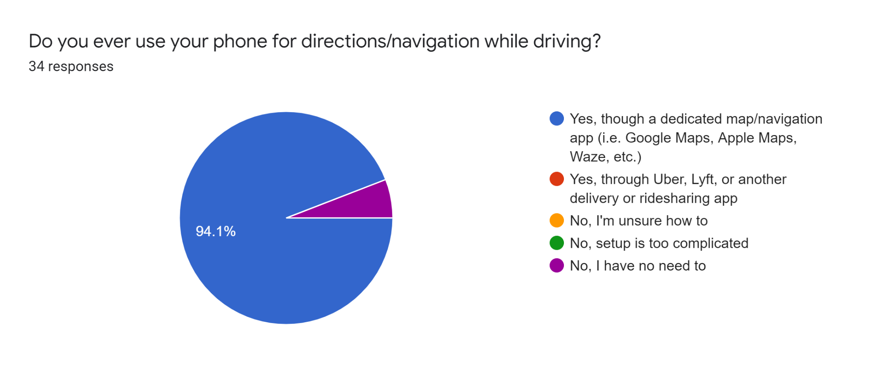

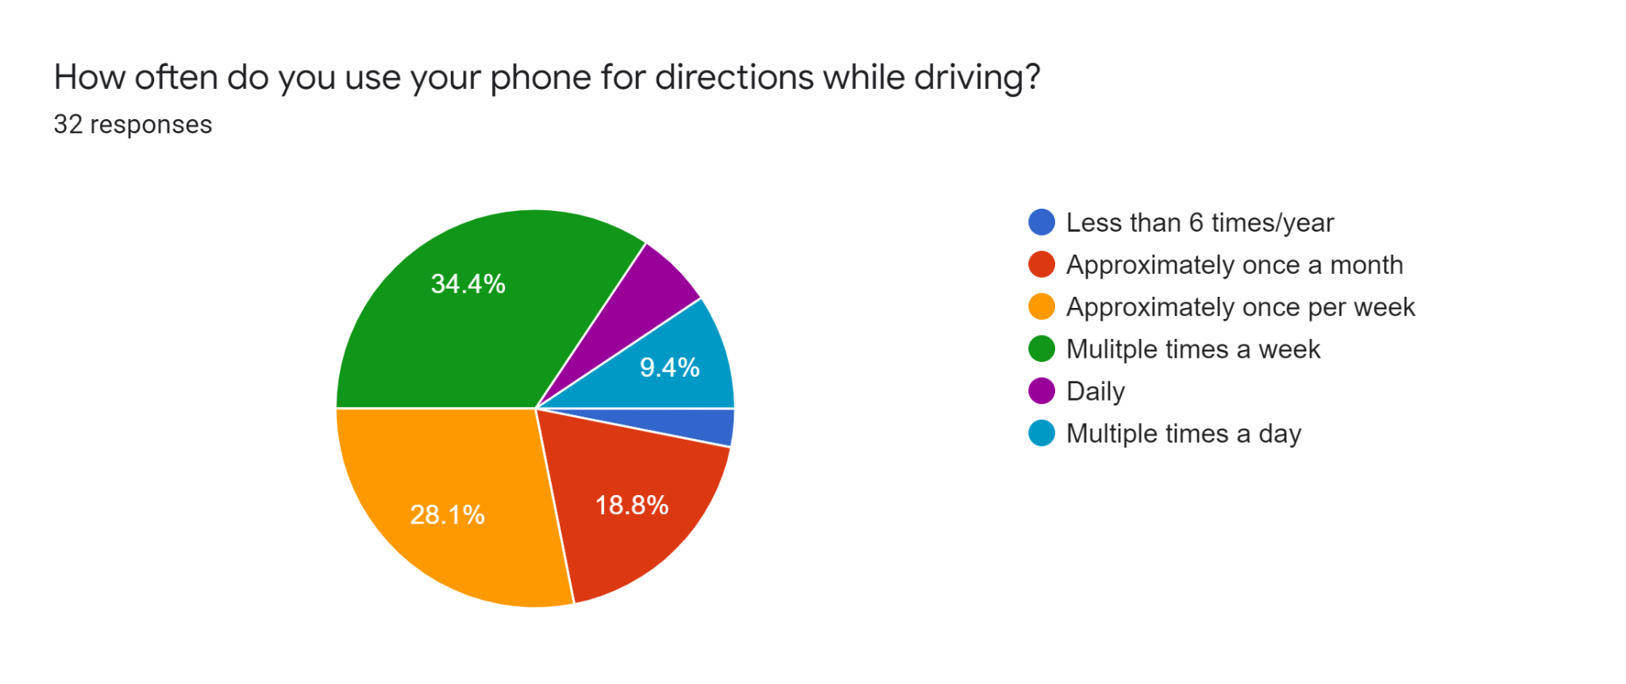

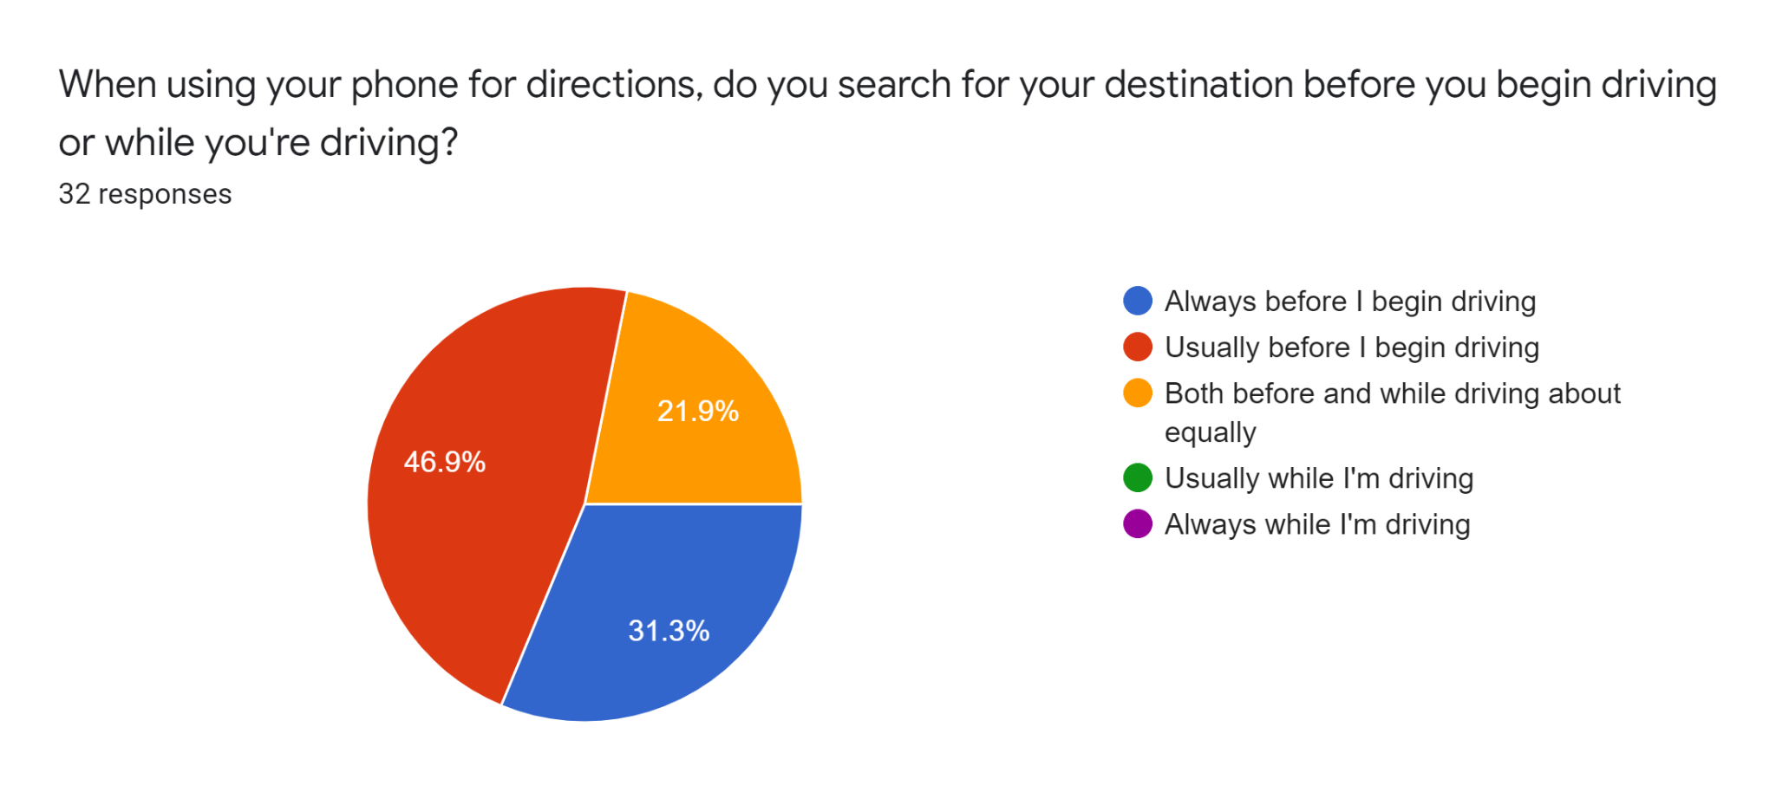

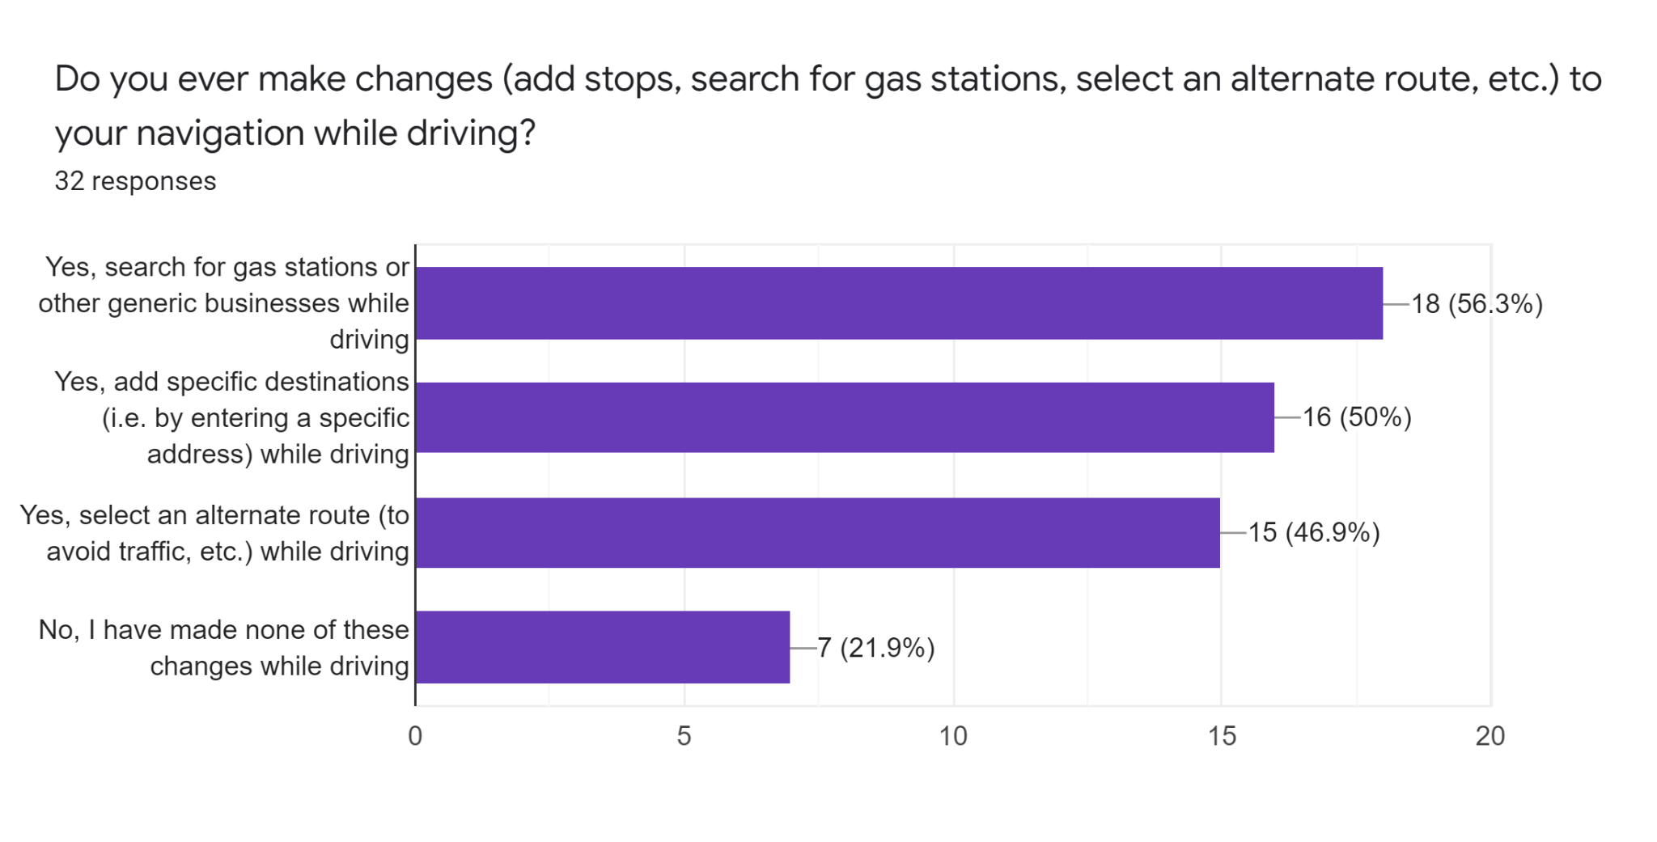

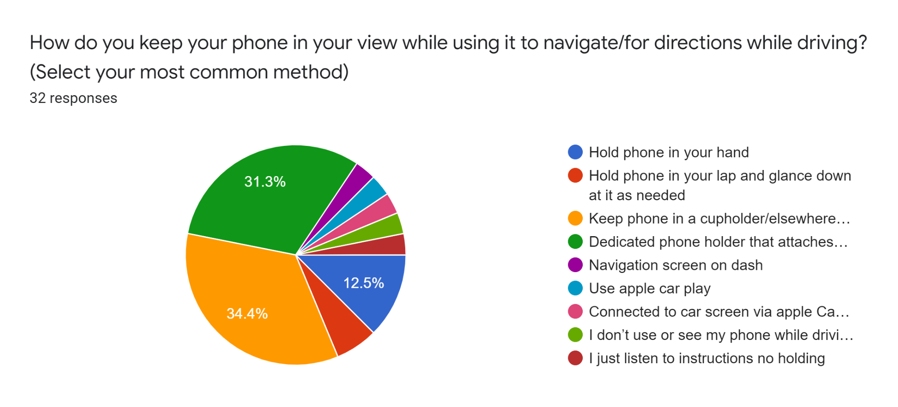

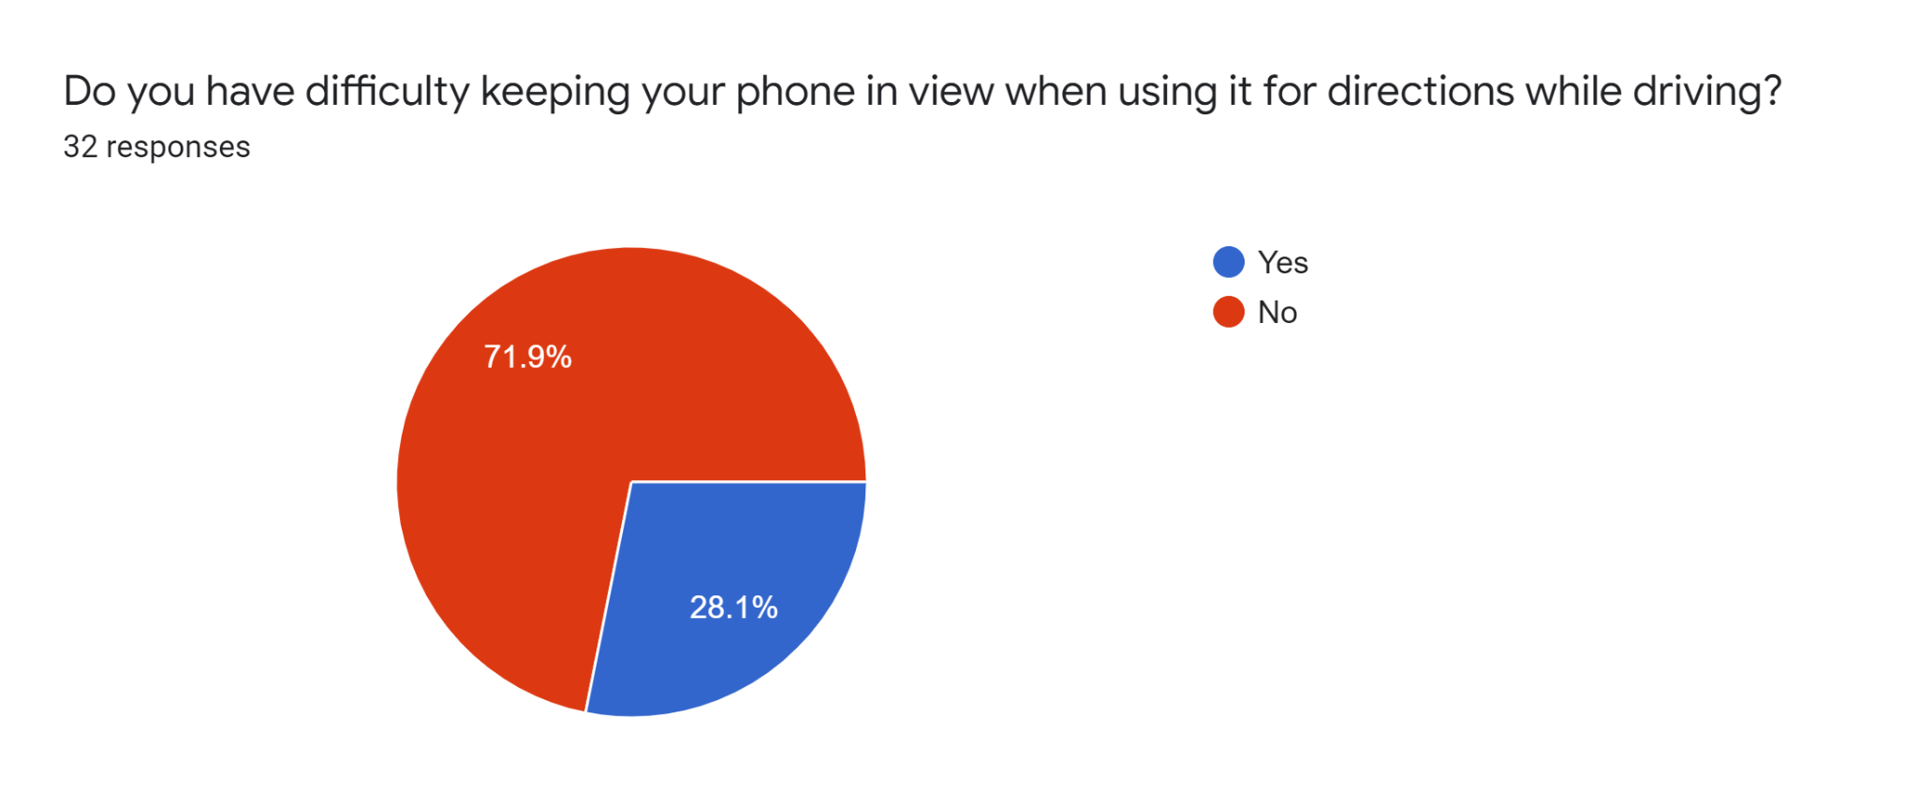

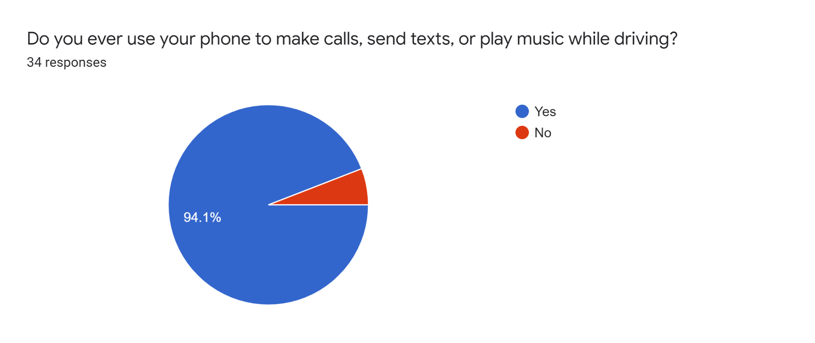

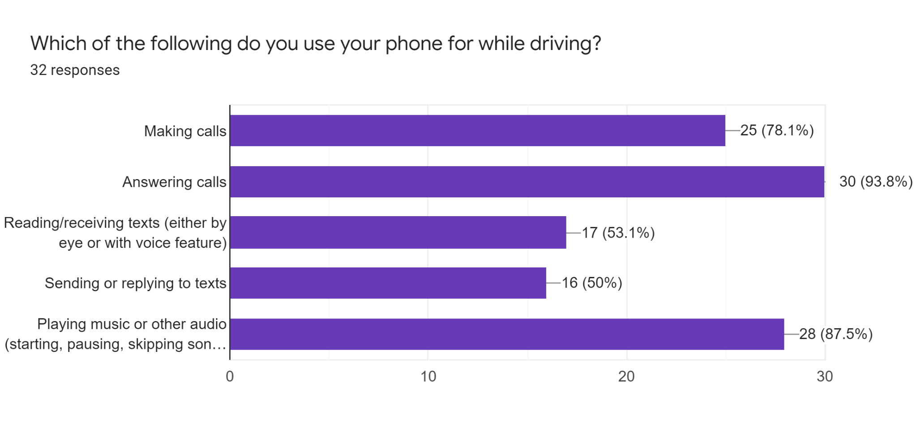

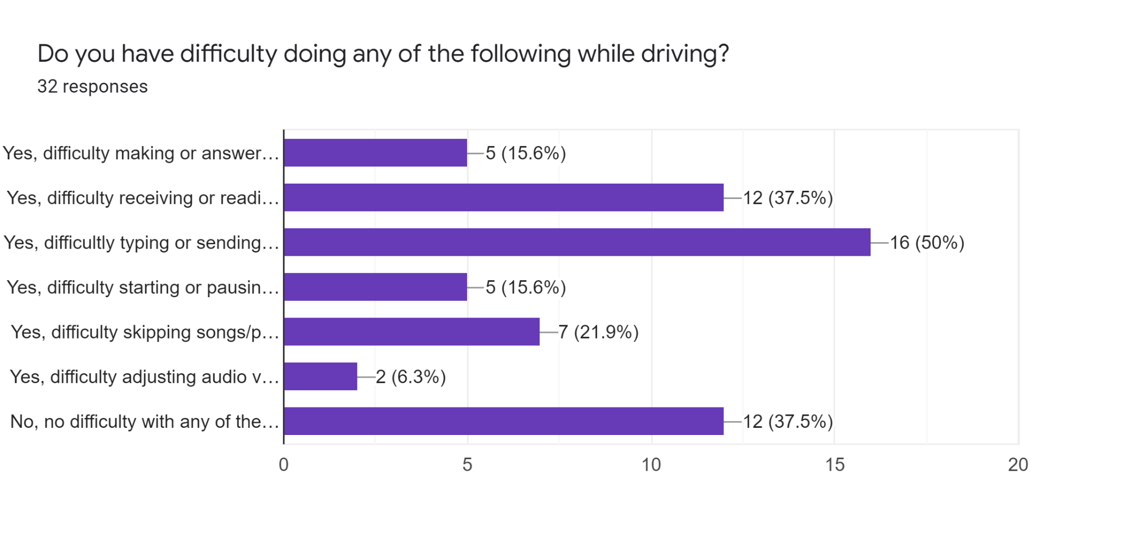

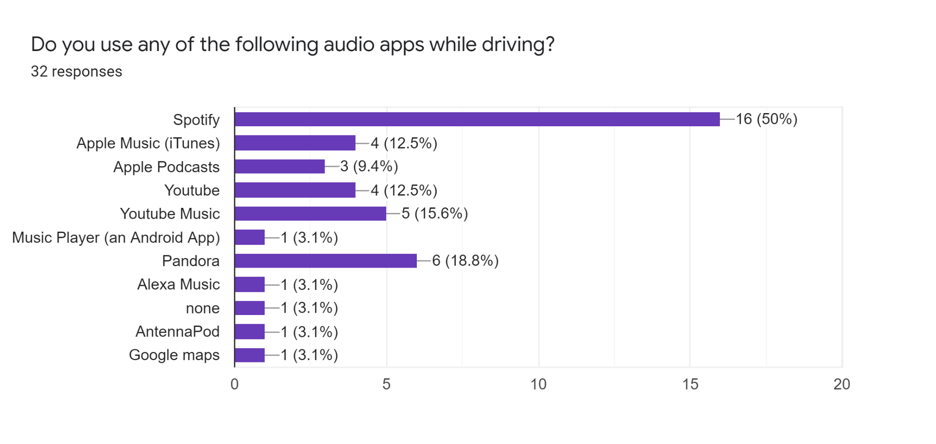

**Pricing Survey**

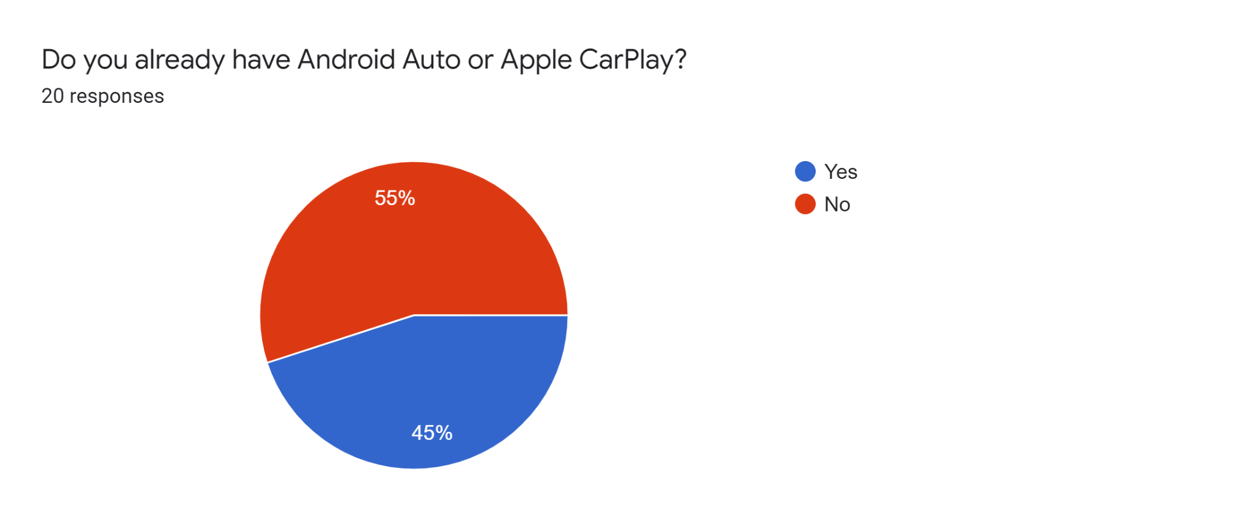

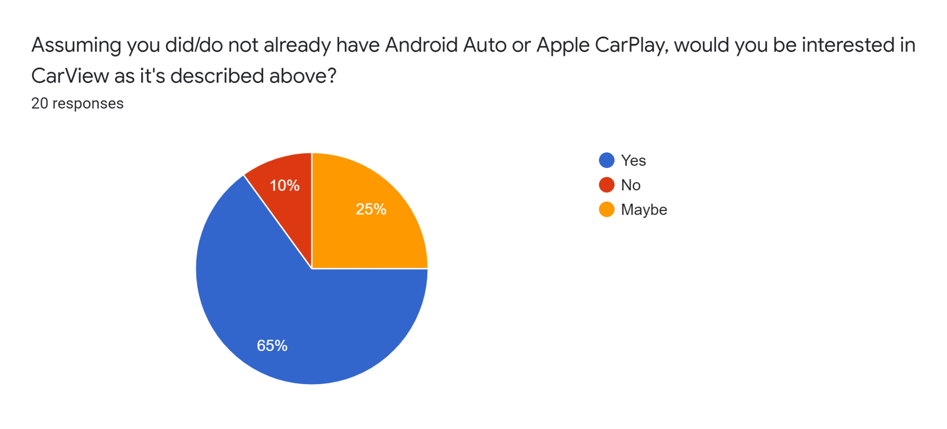

For the following questions we asked the user to: “Please answer the following questions as if you are interested in the CarView app and do not have Android Auto, Apple CarPlay, or any other alternatives.”

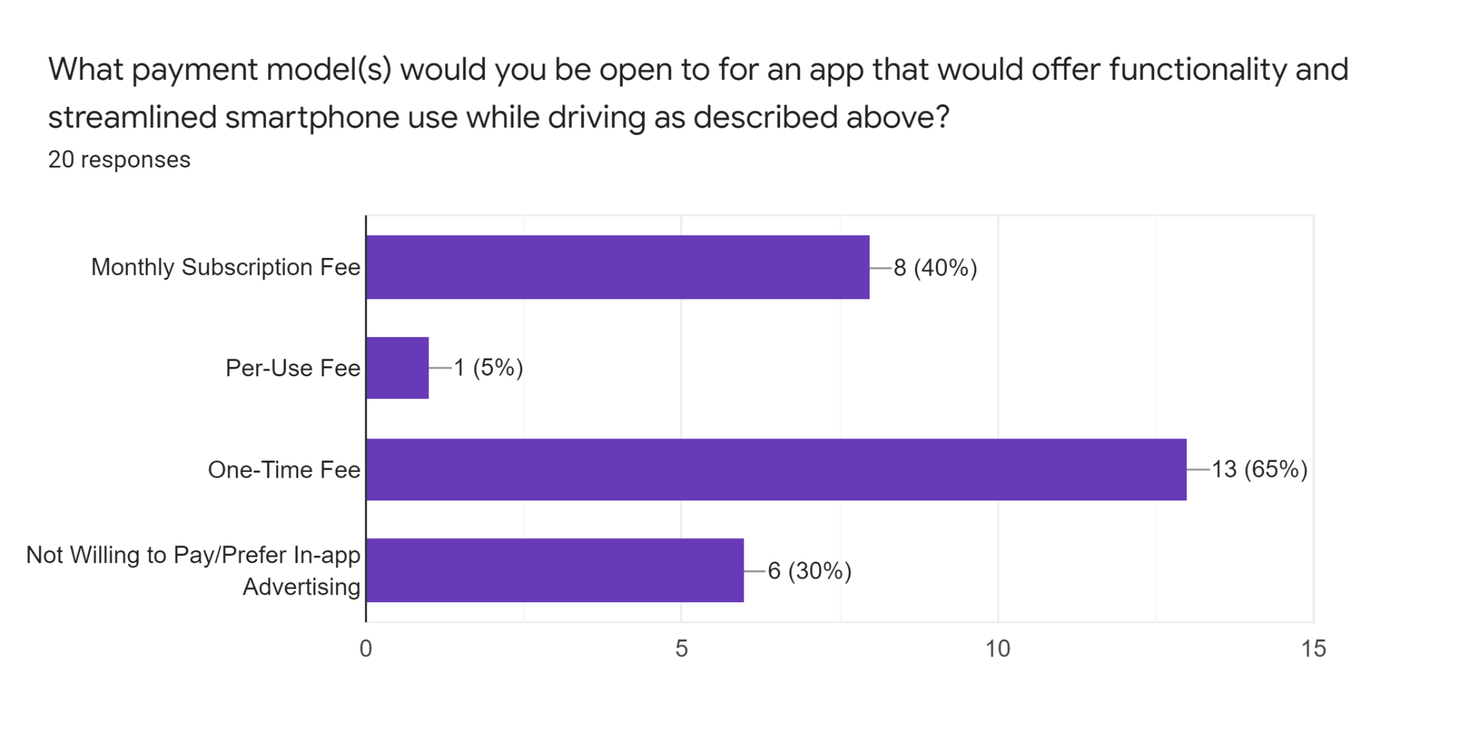

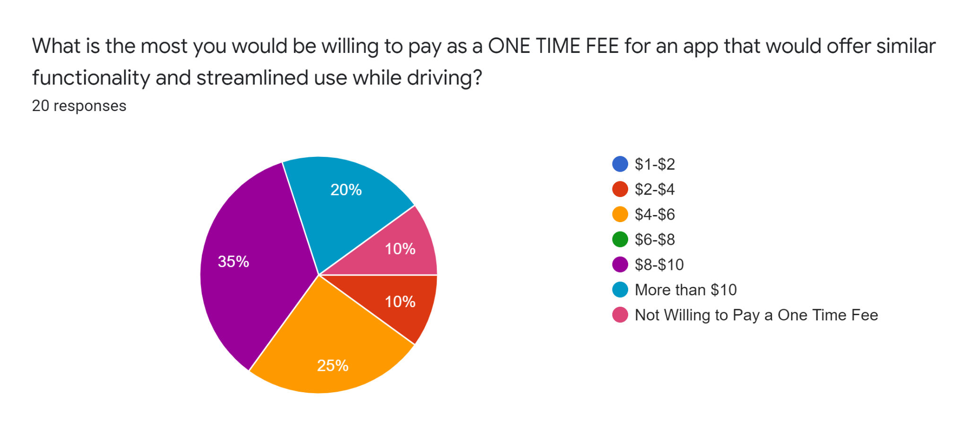

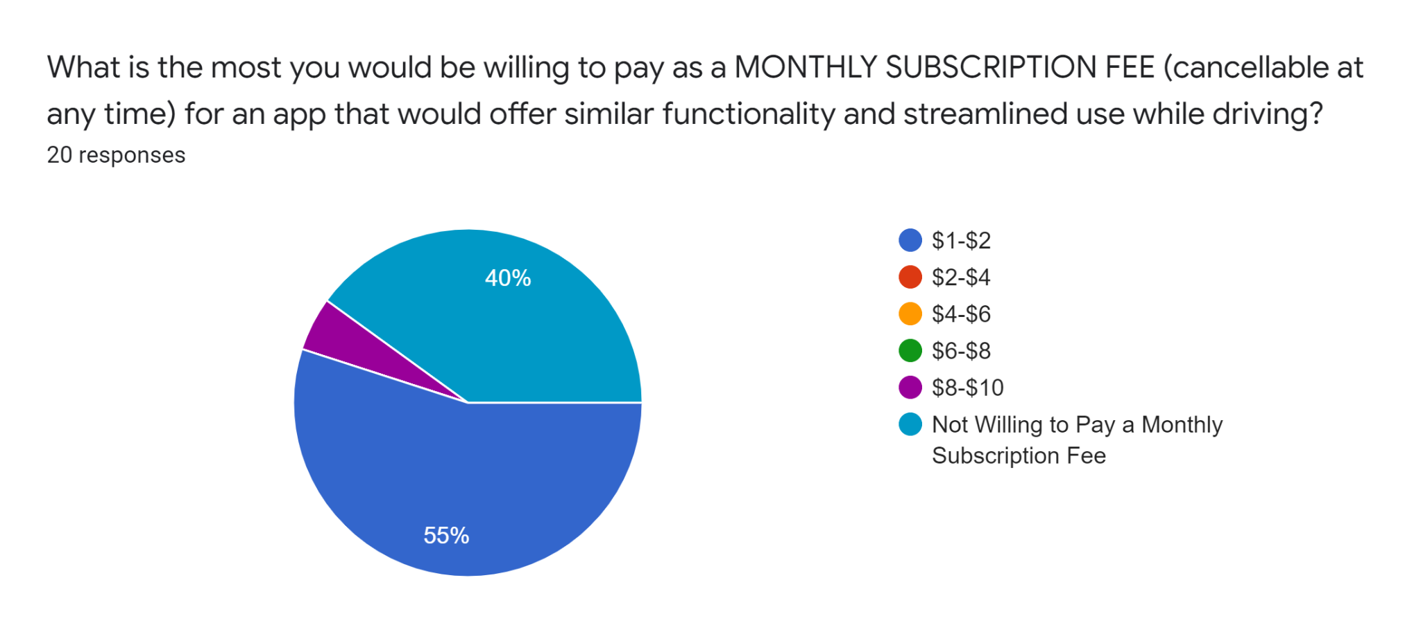

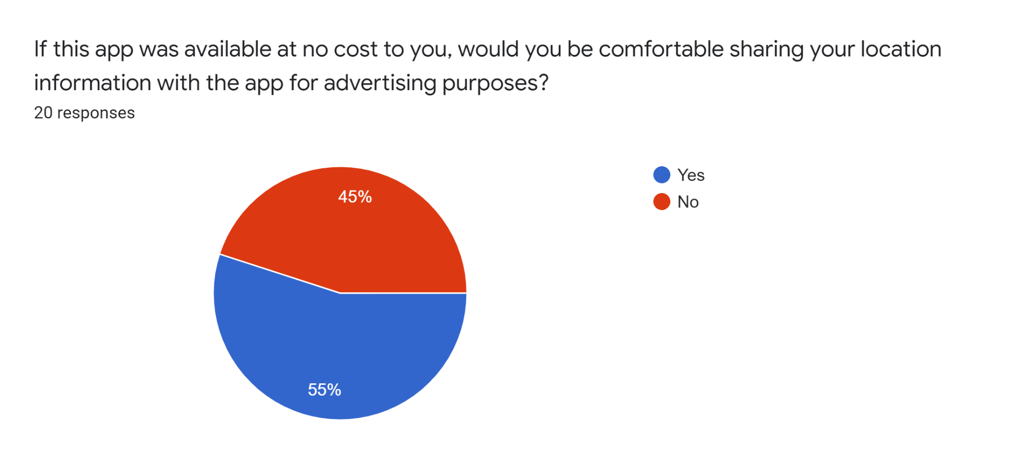

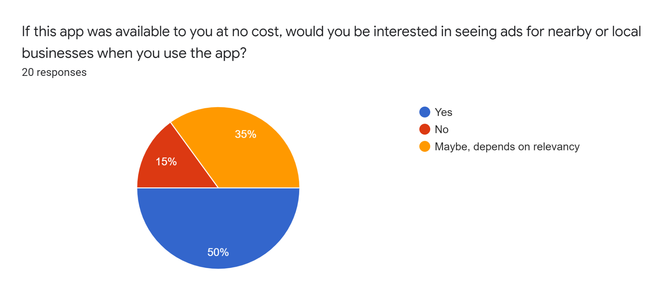

**Think Aloud Protocol**

**Research Questions:**

1. Is the UI sufficiently simple to use while distracted and the majority of the user’s attention must be elsewhere (i.e. on driving, their primary task)?
2. Does using CarView while (simulating) driving result in a significant reduction in driving performance?
   1. Our driving simulator offers 3 performance metrics: time, crashes, and accuracy. We will measure differences in each between a control trial (or an average from several control trials) and the test trial(s) in order to evaluate this question.
3. Can the user successfully accomplish the specified tasks using the interface?

**Usage and Users:**

CarView is intended to be used by drivers, primarily while they are actively engaged in driving. Users may range in age from 16 to over 65, but all would drive a car that is too old or otherwise not equipped with Android Auto or Apple CarPlay. CarView would control the driver’s audio, navigation, and phone calls while they are driving. Our research participants will have no prior experience with CarView, but may have experience with Android Auto or Apple CarPlay, which are similar systems at a high level or in concept and general functionality.

**Setting:**

These think aloud sessions will be conducted in a quiet, private location with minimal distractions. CarView will be loaded on a smartphone for the subject to use, and will be held or mounted to their right hand side around eye level (as it would be for the driver in a vehicle). A driving simulation will be loaded on a laptop placed on a table or desk directly in front of the subject. The test facilitator will have another phone or laptop set up to record the session for later review. If the subject is uncomfortable with video recording, we will ask if audio-only recording is acceptable. Before beginning the test, the facilitator will ask the subject to read and sign a consent form (language below).

The driving simulator we are using for this test is the Parking Game by Drivers Ed Direct (<https://www.driverseddirect.com/game/car-parking/>). Subjects will be asked to play the simulation twice before we introduce CarView to them. These two runs of the simulation are intended to familiarize the subject with its interface, which is relatively simple, and to establish a baseline, not-distracted performance level for the subject. If the initial few subjects struggle more than expected with the simulator’s interface, we will increase the number of control trials per subject - our aim is to reduce any performance differentials between the control trials and the test trial(s) that may result from improved familiarity with the simulator.

Once a performance baseline is established and the user has gained a comfort level with the driving simulator interface, the test facilitator will ask the subject to perform several tasks with CarView (detailed below) while running the simulation again (several times if necessary to complete all of the tasks). The driving simulation offers several levels, we will ask the user to use the same level for all trials (control and test trials) during the session. We acknowledge that the user may improve with the repeated sessions from increased familiarity with the specific level and will reevaluate this procedural decision if that appears to be impacting our results.

In addition to directing the subject through the test procedure, the facilitator will be taking notes, recording control and test trial results for time, crashes, and accuracy, and will be responsible for recording the session. Notes and trial results will be captured in this spreadsheet: [CarView Think Aloud Results](https://docs.google.com/spreadsheets/d/1379rBda3xIjR7yMrnCmYzxHmcwY-EnHA0dT207Jkj-w/edit?usp=sharing).

**Test Trial Tasks:**

1. Initialize navigation to a chosen destination using CarView, before beginning the driving simulation
   1. Navigation will be initialized before beginning the driving simulation as this is the safer practice and is in line with the practice of our initial user survey participants (31.3% always start navigation before beginning to drive and another 46.9% usually do so).
2. Start Spotify audio through the CarView app while (simulating) driving
3. Answer a call through the CarView app while (simulating) driving
   1. The facilitator will place the call at a moment of their choosing
4. Adjust navigation by adding a gas station stop through the CarView app while (simulating) driving

**Support:**

One member of the research team will be present to act as a facilitator for each think aloud session to direct the subject to perform these tasks and to help with navigating the prototype and answer any questions that arise.

**Consent Form Language:**

Thank you for taking the time to be here today. We are students in a Mobile & IoT class at Carnegie Mellon University and our project team is currently developing a mobile application to simplify common tasks while driving. We are here today to conduct research on the effectiveness and usability of our application, CarView.

We are not evaluating either you or your activities. Your identity will be kept confidential - your name will not appear in any document or discussion. The design ideas that emerge will be aimed at improving our app. With your consent, we would like to record our interview with you to review later.

Please remember: your participation is voluntary and you can always decline to answer a question or stop the session at any time.

Please sign below to indicate your consent to be interviewed, observed, and recorded.